Generate Commercial Email Signatures

This is a single page that will take in an employee's data and then generate an HTML signature that they can copy and paste into their signature line.

This was originally developed for J.P. Weigand & Sons Commercial Associates and Support Staff so that no script or manipulation of code would be involved in creating future signatures. Designations for Commercial Associates as well as multiple titles for assistants was all acounted for and implemented in this project.

Technologies Used in this Project

* JavaScript
* HTML/CSS
* JQuery

External Resources

None

Application Setup

**To Setup Development Environment:**

1. Clone/Download this repository on your computer: <https://www.jcchouinard.com/clone-github-repository-on-windows/>
2. Repository Link: <https://github.com/kakes1215/Generate_Signatures>
3. Find the index.html file and double click to open in browser
4. Open folder in any editor to make changes
5. Commit and push any changes made

**To Setup Signature:**

Enter employee details in the respective fields: <https://weigandcommercial.com/generate-signature/index.html>

**[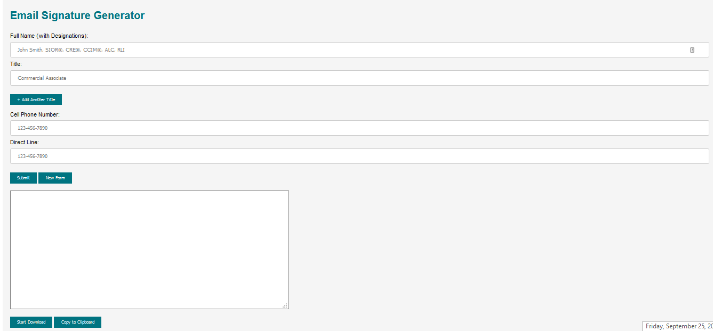](https://github.com/kakes1215/Generate_Signatures/blob/master/images/mainPage.png)**

**Click Submit**

**[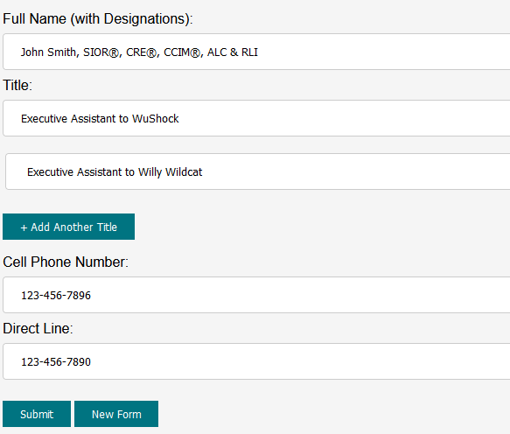](https://github.com/kakes1215/Generate_Signatures/blob/master/images/inputInfo.png)**

**To Copy and Paste the HTML code to Outlook Click Copy to Clipboard and use the following instructions:**

https://www.christopherbolt.com/support/knowledgebase/24/Installing-HTML-email-signatures-in-Microsoft-Outlook.html

**HTML Code should appear**

**[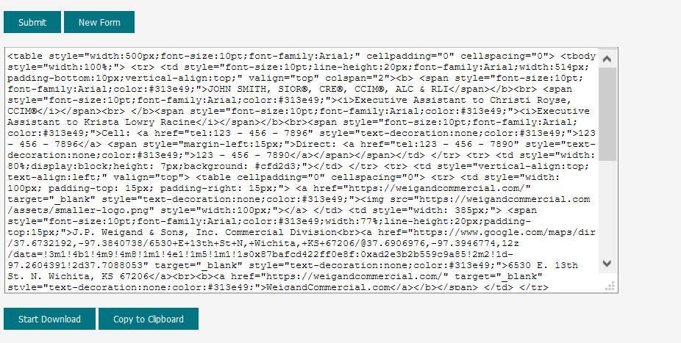](https://github.com/kakes1215/Generate_Signatures/blob/master/images/signatureGenerated.png)**

**Click Start Download**

**Save the file**

**[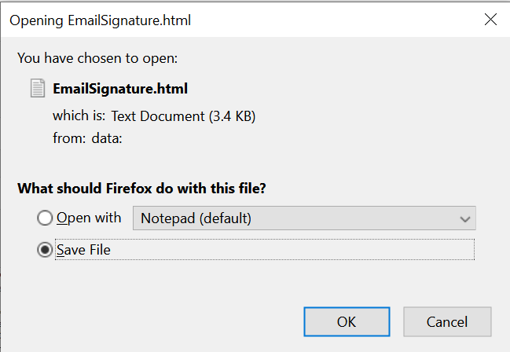](https://github.com/kakes1215/Generate_Signatures/blob/master/images/saveFile.png)**

**Go to Downloads and Double Click to Open File**

**[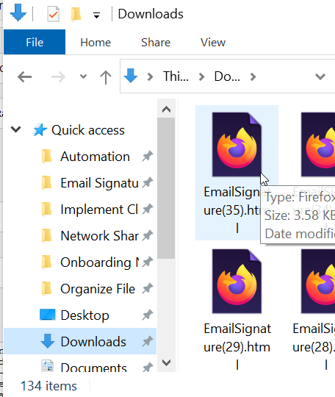](https://github.com/kakes1215/Generate_Signatures/blob/master/images/downloadsPage.png)**

**Signature should now be generated**

**[](https://github.com/kakes1215/Generate_Signatures/blob/master/images/finalSignature.png)**